
support@swifttest.com

3000 Appliance Network Connections

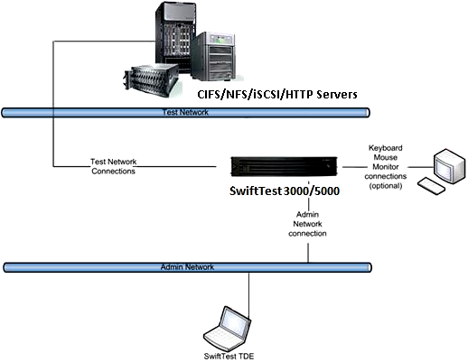

SwiftTest 3000

